**AFFIDAVIT AS TO FACTS**

**Pursuant to Ohio Revised Code §5301.252**

STATE OF OHIO, COUNTY OF Franklin:

Central City Solutions, LLC., being first duly cautioned and sworn, deposes and says that:

1. My name is Central City Solutions and I have personal knowledge of the matters herein stated.

1. This Affidavit pertains to real property located at {{PropertyAddress}} , further described as:

Please See Exhibit A

1. The current owner of the property is {{SellerName}}

1. Central City Solutions is the Buyer and {{SellerName}} is the Seller under the Contract to Purchase Real Estate dated {{ContractDate}} as it pertains to the above listed real estate.

1. A true and accurate copy of the Contract to Purchase Real Estate is attached hereto as Exhibit B.

1. Buyer is ready, willing and able to close.

1. Seller must convey clear title to Buyer and closing may be extended in order for Seller to convey clear title.

1. If closing does not occur pursuant to the timeline identified in Exhibit B it is because Seller is in default.

1. All third parties are hereby on notice of the Contract to purchase the above listed real estate.

And further affiant sayeth naught.



____________________________________

Print Name: Central City Solutions

Sworn to before me and subscribed in my presence this {{NotaryDate}} by Central City Solutions.

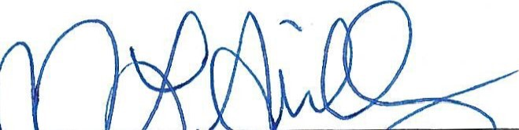

____________________________________

Notary



Prepared by:

Central City Solutions

**EXHIBIT A**

**Legal Description**